Master Document — Team Page Mock Sprint

[Login Restyling Bootstrap] Task 1 —Write Requirements: Team Page & Login Styling
Role | BA — Bevin | Date | 11/08/2026
Completion comment
Done: Documented the required fields for both the team page and log in page in the shared Word document within MS Teams. Specific edge cases for the log in pages have also been specified.
Deliverable: Requirements document saved in MS Teams shared folder.
Note for next role: UX – Feel free to ask if you any questions or confusion with the requirements. If you wish to add extra features that you need to confirm with me or the team, ask.

[Login Restyling Bootstrap] Task 2 — Design Login Style & Team Page Layout
Role | UX — Asbi | Date | 12/08/2026
Completion comment
Done: Created wireframes for the Sign In, Create New Account, Forgot Password, and Team pages based on the BA requirements. The login and team page layouts were designed to be visually consistent.
Deliverable: Added to the shared requirement and design document in MS Teams.
Note for next role: BA — please review the wireframes against the agreed requirements and confirm that the proposed layouts and user flow are suitable before development begins. Any required changes can be updated before the designs are handed over to the developers.
Login page wireframe:
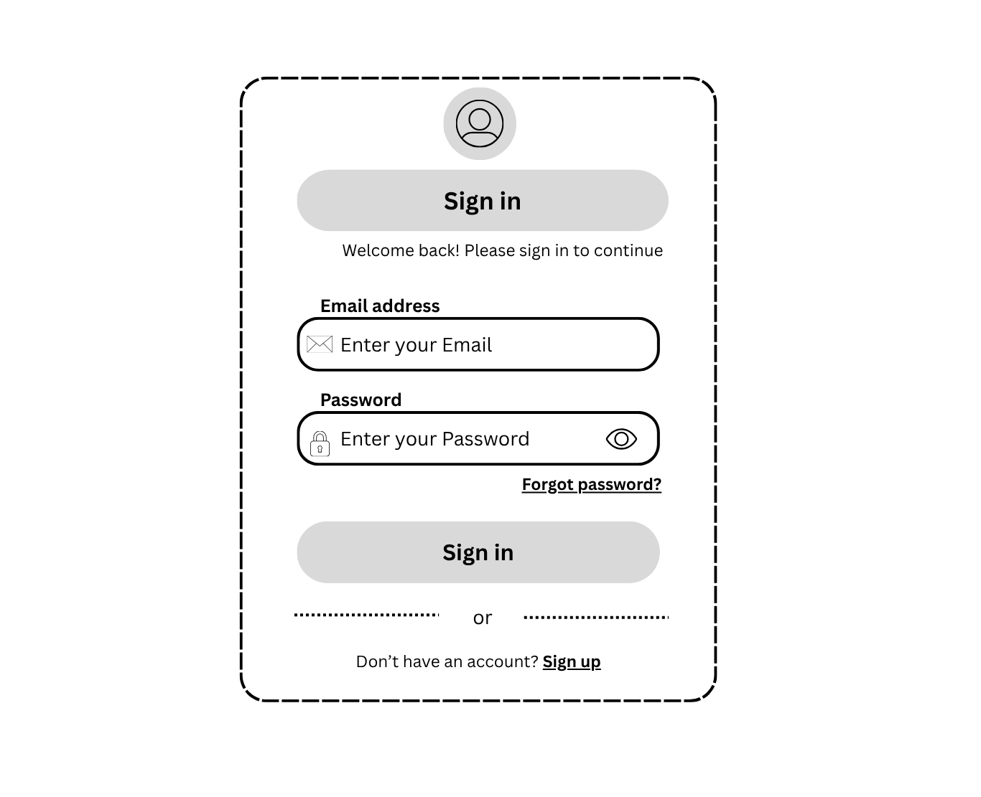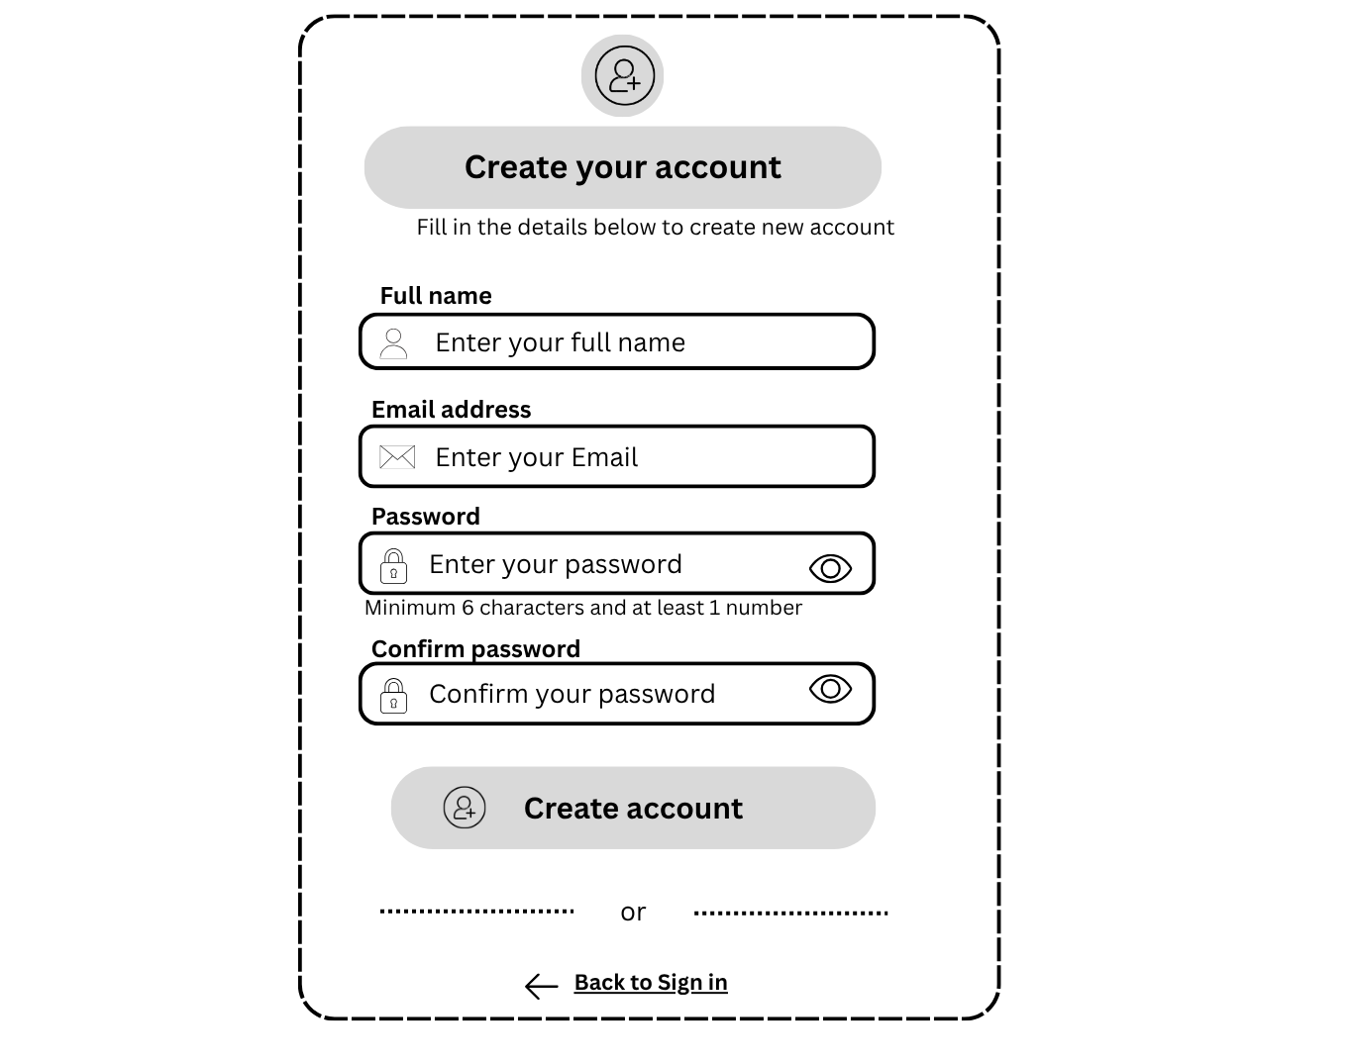
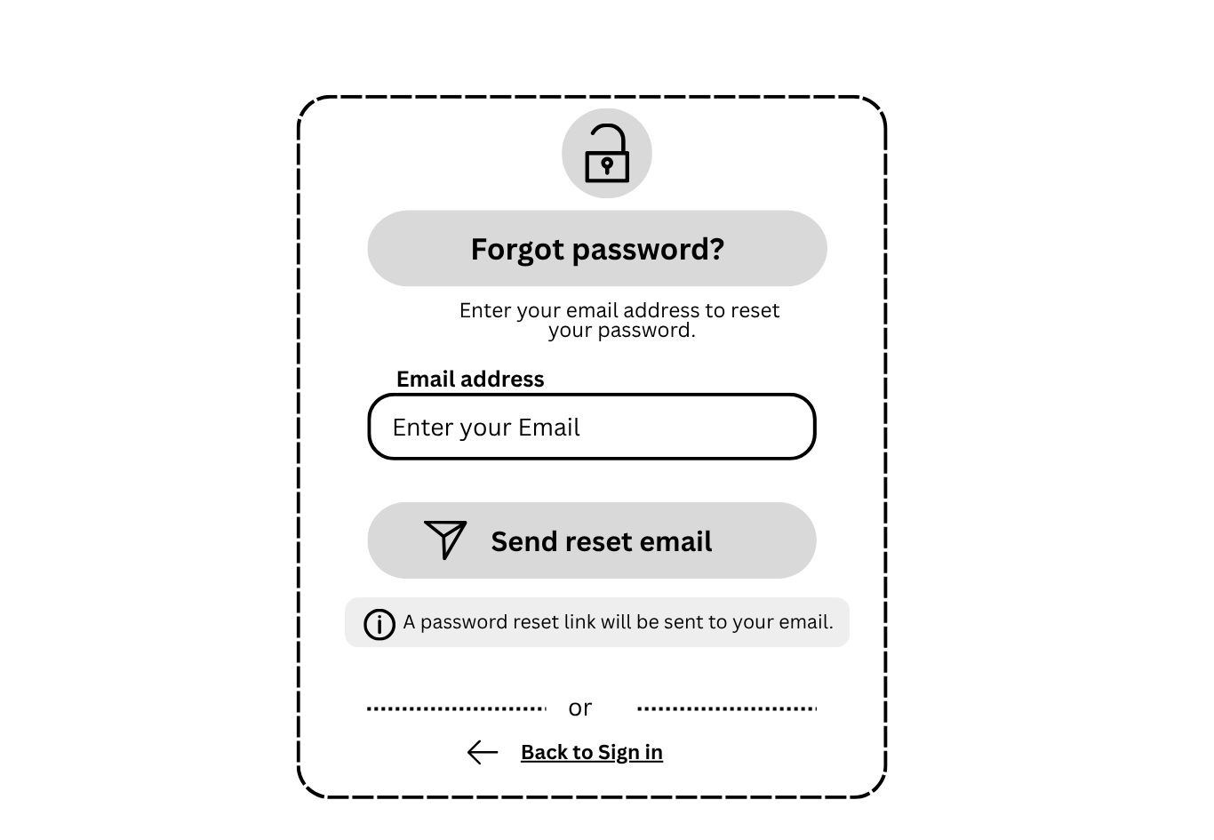
Team page wireframe:
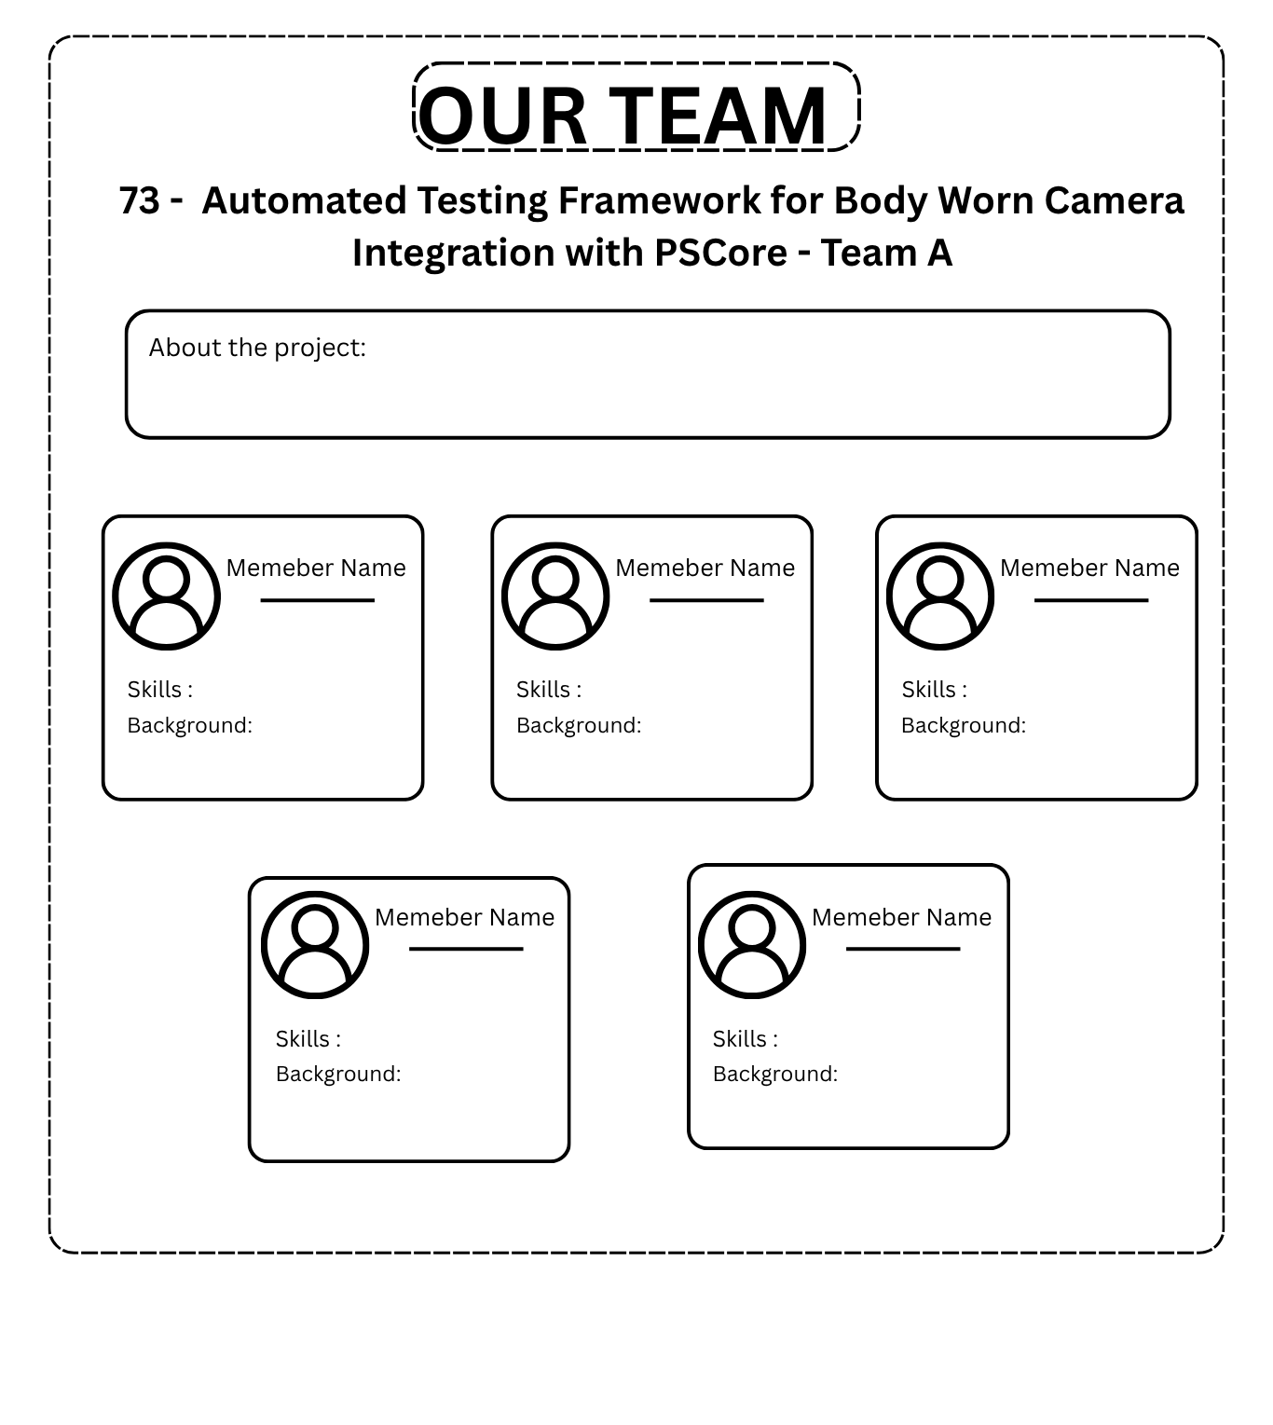

[Login Restyling Bootstrap] Task 3 — Validate Design Against Requirements
Role | BA — Bevin | Date | 12/08/2026
Completion comment
Done: All wireframes checked against the requirements; log in page contains all the elements that was specified, no complaints. However, the team page: different members have differing levels of detail in their skills and background section. This may cause inconsistency with the sizing of the boxes allocated to each team member.
Deliverable: Wireframes now validated
Note for next role: Add a “read more” function/button to expand the entire text if the user wishes to read more about the user. This ensures that the team boxes will all be the same size by default UNTIL the user expands it.

[Login Restyling Bootstrap] Task 4 — Style Login Page
Role | Dev 1 — Jesse | Date | 13/08/2026
Completion comment
Done: Styling of login page wireframes applied to existing login page code. No authentication logic changes applied.
Deliverable: Login page styling updated based on approved UX design
Note for next role: Dev 2 to regression test changes
Git URL (PR): feat(auth): Align sign-in, sign-up, and forgot-password pages with UX wireframe by s4002576 · Pull Request #9 · KAX17ss7/Programming-Project-A1 · GitHub
REAL OUTPUT — rendered login page
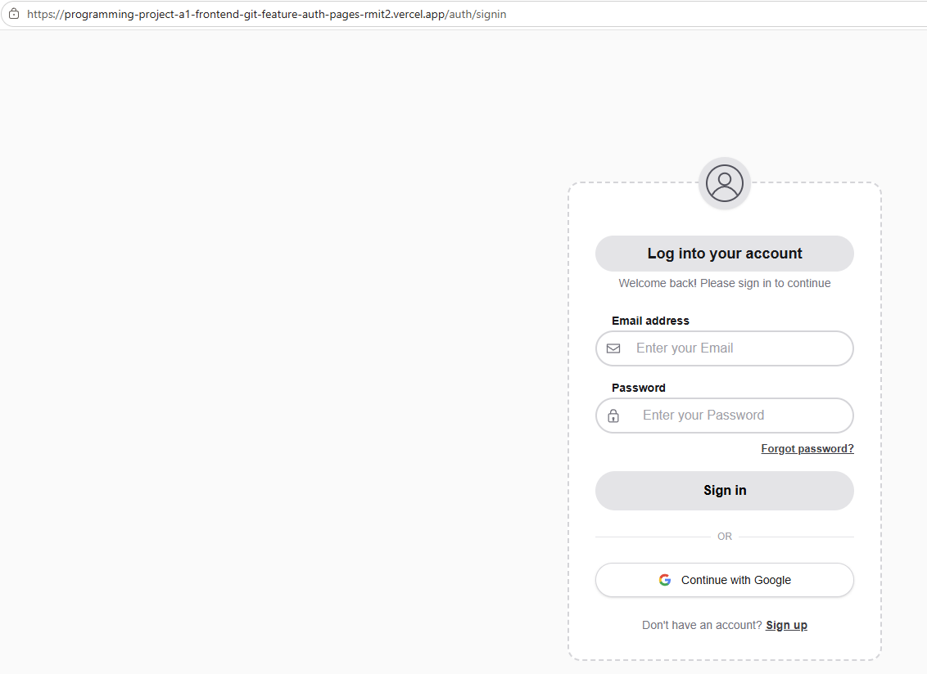

[Login Restyling Bootstrap] Task 5 — Build Team Page & Auth Redirect
Role | Dev 1 — Jesse | Date | 14/08/2026
Completion comment
Done: Team page renders per design with all required field, and successful login redirects to team page which is not accessible without login.
Deliverable: Team page created and is accessible only to authenticated users
Note for next role: Perform end to end test of redirection including cases outside of “happy path”.
Git URL (PR): feat(team): Add team page with profiles and data by s4002576 · Pull Request #10 · KAX17ss7/Programming-Project-A1 · GitHub
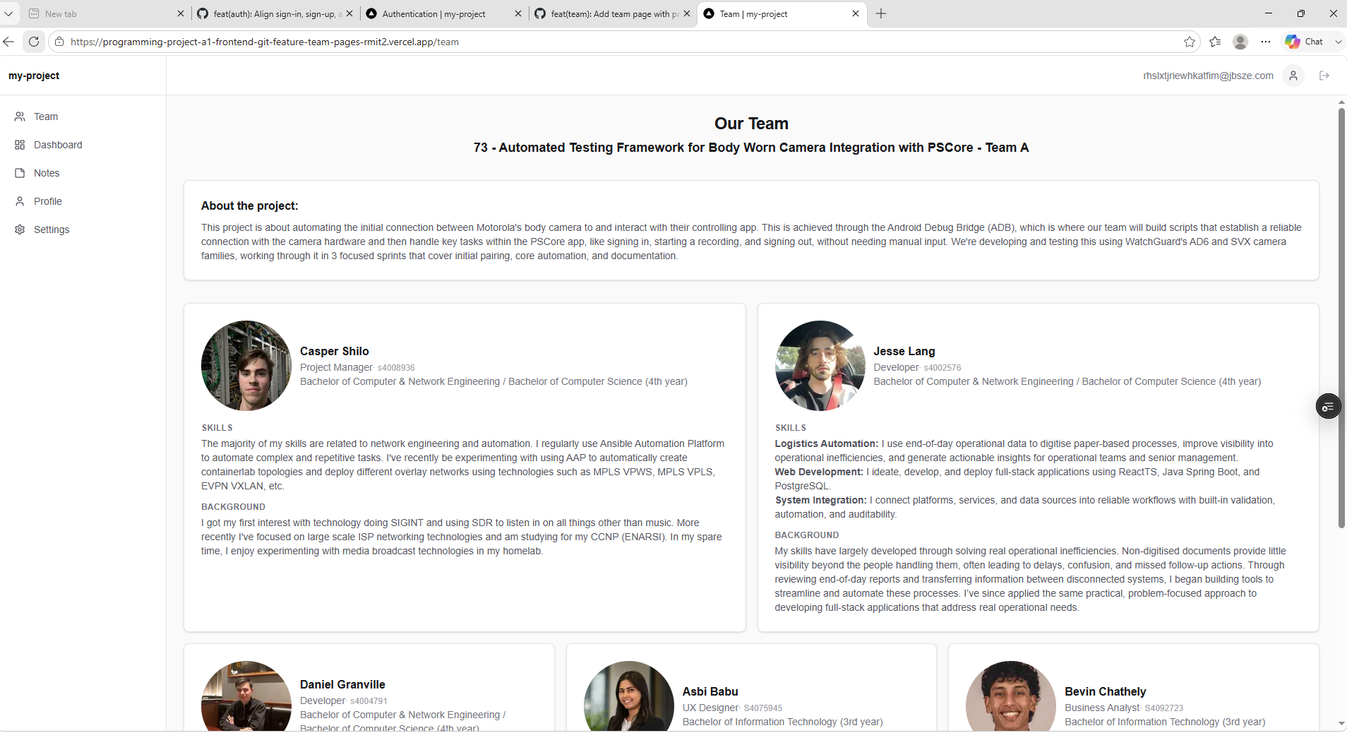

[Login Restyling Bootstrap] Task 6 — Deploy
Role | Dev 1 — Jesse | Date | 14/08/2026
Completion comment
Done: Features from both PR merged into staging branch. Vercel deployment protection disabled to allow staging branch to be accessed for testing
Deliverable: Vercel deployment of staging branch successful.
Note for next role: Use below URL to access pre-production Vercel release.
Vercel staging preview (URL): Home

[Login Restyling Bootstrap] Task 7 — Test Login → Redirect → Team Page Flow
Role | Dev 2 — Daniel | Date | 14/08/2026
Completion comment
Done: Testing for login screen to redirect to team-page completed successfully upon correct login detail put into sign in form.
Deliverable: Successful verification. Results documented here: Edge Case and Bug Documentation.docx
Note for next role: Dev 2 - Add different combination of login edge test cases such as one or both login fields being incorrect or and email with the ‘@’.

[Login Restyling Bootstrap] Task 8 — Test Edge Cases & Log Bugs
Role | Dev 2 — Daniel | Date | 14/08/2026
Completion comment
Done: Completed edge case testing for various parts of the webpages including sign in pages, sign up page, loading all webpages using sidebar, leaving a note. No bugs were found while testing on any page.
Deliverable: Edge Case and Bug Documentation containing evidence of edge cases. Results documented here: Edge Case and Bug Documentation.docx
Note for next role: PM – Please review and provide feedback if more documentation is needed for edge case testing.

[Login Restyling Bootstrap] Task 9 — Final Review & Sign-Off
Role | PM — Casper | Date | 16/08/2026
Completion comment
Done: All acceptance criteria for all tasks have been validated, and closure comments copied to master document where not done by implementer. Master document verified to capture all tasks correctly, and all tasks in planner board “completed” and moved to “Done” bucket.
Deliverable: Master document, Team reflection, Individual reflection, and planner board signed off and uploaded to Github.
Note for next role: N/A
Git URL: https://github.com/KAX17ss7/Programming-Project-A1/pull/14

